**Newry Cathedral Parish**

**BOOK OF REMEMBRANCE**

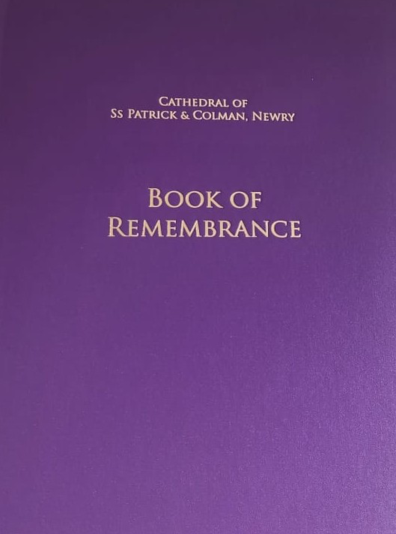

The Bereavement Ministry have organised a BOOK OF REMEMBRANCE for the Cathedral. It will be situated at Our Lady’s Altar beside the Sacristy.

The pages will be displayed on the date of death and prayers will be offered for all whose names are written there.

If you would like the name of your departed loved one to be included in this BOOK, please fill in the details below and return it to the parish office.

********************************************************************************************

NAME of the deceased: (IN BLOCK CAPITALS) _________________________

EXACT DATE OF DEATH

DATE:_______ MONTH:__________ YEAR: ____



Contact Name ………………………………….......

Tel. No ..................................................................

Email:………………………………………………….

Receive the weekly parish bulletin by email (please circle) Yes / No

We will use this information for the book of remembrance and (optionally) to email you the weekly parish bulletin. Your details will be stored securely and will not be shared. Return to the Parish Office 38-40 Hill Street Newry Co. Down BT34 1AT Tel. No.028 3026 2586

**Only one name per form**