Dromore Diocese –

Climb Croagh Patrick
Wednesday 20th and Thursday 21st June 2018
Join others on an Adventure of Faith –
Walk, Climb, Laugh, Pray a little......

Join others on an Adventure of Faith, Walk, Climb, Laugh, Help, Support and Pray a little...

Not to be missed ... for those 16 years up to 20 something ...
Complete and return the REGISTRATION FORM

B & B in Knock @ the International Hostel, plus a Mini Retreat together....
Places are limited - sign up before the end of June.....

£40 includes Bus, Knock visit,
B & B, a packed lunch for Croagh Patrick Walk/Climb.

Transport: Bus will leave from Hilltown, pick up points, Mayobridge, Newry and Lurgan.

Times will be confirmed on the week prior to departure.

(by prior arrangement we will pick up others on route.)

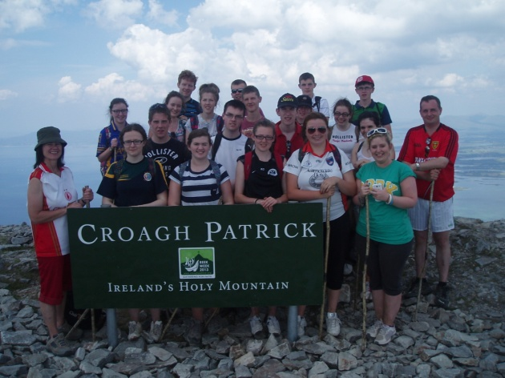

Book your place now...

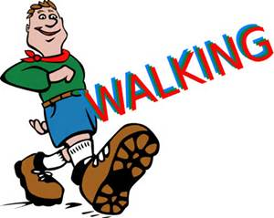

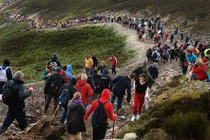
Dromore Diocesan Youth Commission
Consent Form to be completed and signed by Parents/Guardians

Activity – Pilgrimage: Climb Croagh Patrick (Mayo) and Retreat Experience in Knock
And on Route stop in Belcoo for Lunch (own packed lunch)

Date: Depart early Tuesday 19th June & Wednesday 20th June.

Leader: Frances McNally, plus other Parish Leaders.

Name of Young Person __________________________ Date of Birth __/___/___

Name of Parent/Guardian _____________________________________________

Address ___________________________________________________________

Postcode__________________Home Ph No. _____________ Mobile No. ___________

An itinerary for the Pilgrimage will be forward to all Parents/Participants/Leaders.
It is the responsibility of parents/guardians to draw to the attention of the group leaders, any special requirements that your daughter/son may have, e.g. dietary, allergies, medical conditions, medications, for which special arrangements should be made or consent obtained.
Please indicate special requirements on the lines below:
________________________________________________________________________

All young people Climbing Croagh Patrick must provide the following.
- Walking boots or strong trainers/bring a waterproof jacket.
- Wear Track bottoms, bring warm fleece and cap.
- Bring a packed lunch for journey to Knock, plus extra crisps, biscuits etc for climb next day.
- Bring a drinking water for bus journey for walk/climb.
- A small hold all (Old school bag) to carry the above)

Transport: Collection Points:- Hilltown – Warrenpoint – Newry – Lurgan.
Times will be confirmed to all parents prior to departure.
Please note the media or public relations for programme delivery purposes may photograph your son/daughter. If you do not wish your son/daughter to be photographed please state on the line below:
_________________________________________________________________________
If the Diocesan/Parish (leaders/coordinators) are unable to contact you in an emergency, do you agree to your child being placed in the care of medical staff? - Please delete as appropriate YES / NO

I encourage my daughter/son to participate positively in this activity; showing due respect to others in the group; the leaders and others whom they will meet; plus the transport used and all venues visited

To the best of my knowledge my daughter/son is both medically and physically fit to Climb Croagh Patrick – (A mountain walk that will take up to 6 hours return) - Please delete as appropriate YES / NO

I enclose £20 deposit toward cost of this activity – (this is non-refundable if cancelled 2 weeks prior to departure) £20 balance is due on or before 6th June. (£40 is to cover the cost of this activity – transport; accommodation and retreat in Knock, plus packed lunch for climb/walk up Croagh Patrick.
PRINT NAME _________________________ Date __/___/18

SIGNED ____________________________ Emergency No __________________
(Parental Consent Only for Under 18’s)
Please return completed form and fee (Cheques payable to Diocese of Dromore Youth Commission) to your Parish Youth Leader or Post to Youth Ministry Office, 38-40 Hill St, Newry, Co. Down BT34 1AT please encourage others to come along for those 16 years plus to 20 ish....

